***MNGT 370***

*T Score Facet Means*

As MNGT 370 is taught ***year-round***, the average score represents an academic year average.

The vertical gray line differentiates between pre- and post-mid-tenure review. This demarcation highlights how my performance improved following feedback.

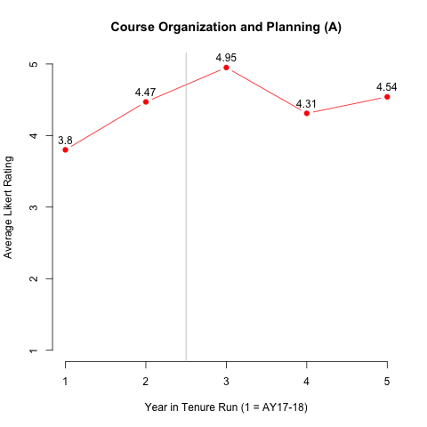

***MNGT 425***

*T Score Facet Means*

As MNGT 425 is ***spring-only***, the means represent only the average for the course taught in the spring.

The vertical gray line differentiates between pre- and post-mid-tenure review. This demarcation highlights how my performance improved following feedback.

***MNGT 475***

*T Score Facet Means*

As MNGT 425 is ***fall-only***, the means represent only the average for the course taught in the fall.

The vertical gray line differentiates between pre- and post-mid-tenure review. This demarcation highlights how my performance improved following feedback.

***MNGT 502***

*T Score Facet Means*

As MNGT 502 is taught ***year-round***, the average score represents an academic year average.

The vertical gray line differentiates between pre- and post-mid-tenure review. This demarcation highlights how my performance improved following feedback.